**DLB Lab -4**

Tasks

Roll no: 23K-2001

BCS 2-J

***Exercise#01 & Exercise#02:***

***Exercise#03:***

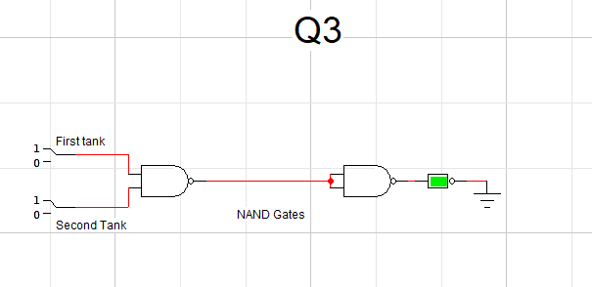

***Exercise#04:***

***Exercise#05:***

|  |  |  |  |
| --- | --- | --- | --- |
| ***Tire A*** | ***Tire B*** | ***Tire C*** | ***Output(green)*** |
| ***0*** | ***0*** | ***0*** | ***1*** |
| ***0*** | ***0*** | ***1*** | ***0*** |
| ***0*** | ***1*** | ***0*** | ***0*** |
| ***0*** | ***1*** | ***1*** | ***0*** |
| ***1*** | ***0*** | ***0*** | ***0*** |
| ***1*** | ***0*** | ***1*** | ***0*** |
| ***1*** | ***1*** | ***0*** | ***0*** |
| ***1*** | ***1*** | ***1*** | ***0*** |

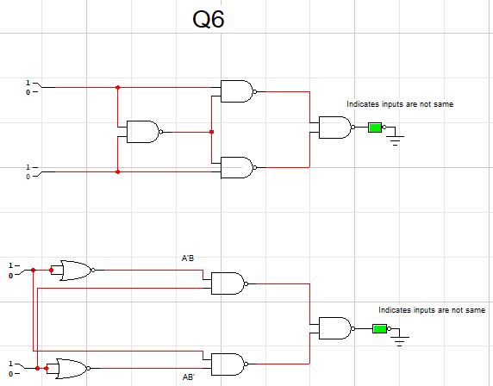***Exercise#06:***

|  |  |  |
| --- | --- | --- |
| ***Xor Table*** | | |
| ***0*** | ***0*** | ***0*** |
| ***0*** | ***1*** | ***1*** |
| ***1*** | ***0*** | ***1*** |
| ***1*** | ***1*** | ***0*** |

***True/False***

1. ***True***
2. ***True***
3. ***False***
4. ***False***
5. ***True***
6. ***True***
7. ***False***